Week-01 HandsOn Solution

- Design Patterns and Principles

Exercise 1: Implementing the Singleton Pattern

- Code:

using System;

public class Logger{
private static Logger? instance;
private static readonly object lockObj = new object();

private Logger() { }

public static Logger Instance
{
get
{
lock (lockObj)
{
if (instance == null)
instance = new Logger();
return instance;
}
}
}

public void Log(string message){
Console.WriteLine("Log: " + message);
}
}

public class Program{
public static void Main()
{
Logger log1 = Logger.Instance;
Logger log2 = Logger.Instance;
log1.Log("First message");
Console.WriteLine(log1 == log2);
}
}

- Output:

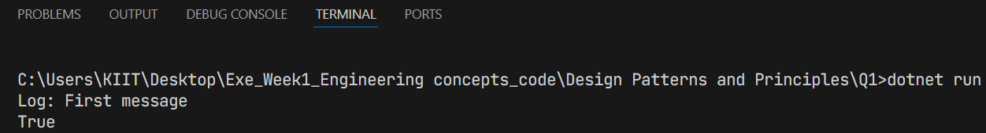

Exercise 2: Implementing the Factory Method Pattern

- Code:

using System;

interface IDocument{
void Open();
}

class WordDocument : IDocument{
public void Open() => Console.WriteLine("Word document opened.");
}

class PdfDocument : IDocument{
public void Open() => Console.WriteLine("PDF document opened.");
}

abstract class DocumentFactory{
public abstract IDocument CreateDocument();
}

class WordFactory : DocumentFactory{
public override IDocument CreateDocument() => new WordDocument();
}

class PdfFactory : DocumentFactory{
public override IDocument CreateDocument() => new PdfDocument();
}

public class Program{
public static void Main(){
DocumentFactory factory = new PdfFactory();
IDocument doc = factory.CreateDocument();
doc.Open();
}
}

- Output:

Exercise 3: Implementing the Builder Pattern

- Code:

using System;

class Computer{
public string CPU { get; private set; }
public string RAM { get; private set; }
public string Storage { get; private set; }

private Computer() { }

public class Builder{
private Computer computer = new Computer();

public Builder SetCPU(string cpu) { computer.CPU = cpu; return this; }
public Builder SetRAM(string ram) { computer.RAM = ram; return this; }
public Builder SetStorage(string storage) { computer.Storage = storage; return this; }
public Computer Build() => computer;
}
}

public class Program{
public static void Main(){
var pc = new Computer.Builder().SetCPU("i7").SetRAM("16GB").SetStorage("1TB").Build();
Console.WriteLine($"CPU: {pc.CPU}, RAM: {pc.RAM}, Storage: {pc.Storage}");
}
}

- Output:

Exercise 4: Implementing the Adapter Pattern

- Code:

using System;

interface IPaymentProcessor{
void ProcessPayment();
}

class OldPaymentGateway{
public void MakePayment() => Console.WriteLine("Payment done using old gateway.");
}

class PaymentAdapter : IPaymentProcessor{
private OldPaymentGateway gateway = new OldPaymentGateway();
public void ProcessPayment() => gateway.MakePayment();
}

public class Program{
public static void Main(){
IPaymentProcessor processor = new PaymentAdapter();
processor.ProcessPayment();
}
}

- Output:

Exercise 5: Implementing the Decorator Pattern

- Code:

using System;

interface INotifier{
void Send(string message);
}

class EmailNotifier : INotifier{
public void Send(string message) => Console.WriteLine("Email: " + message);
}

abstract class NotifierDecorator : INotifier{
protected INotifier wrappee;
public NotifierDecorator(INotifier notifier) { wrappee = notifier; }
public virtual void Send(string message) => wrappee.Send(message);
}

class SMSNotifier : NotifierDecorator{
public SMSNotifier(INotifier notifier) : base(notifier) { }
public override void Send(string message)
{
base.Send(message);
Console.WriteLine("SMS: " + message);
}
}

public class Program{
public static void Main(){
INotifier notifier = new SMSNotifier(new EmailNotifier());
notifier.Send("Hello!");
}
}

- Output:

Exercise 6: Implementing the Proxy Pattern

- Code:

using System;

interface IImage{
void Display();
}

class RealImage : IImage{
private string filename;

public RealImage(string filename){
this.filename = filename;
LoadFromDisk();
}
private void LoadFromDisk(){
Console.WriteLine("Loading " + filename);
}

public void Display(){
Console.WriteLine("Displaying " + filename);
}
}

class ProxyImage : IImage{
private RealImage? realImage;
private string filename;

public ProxyImage(string filename){
this.filename = filename;
}

public void Display(){
if (realImage == null)
{
realImage = new RealImage(filename);
}
realImage.Display();
}
}

class Program{
static void Main(){
IImage img = new ProxyImage("image1.jpg");
img.Display();
img.Display();
}
}

- Output:

Exercise 7: Implementing the Observer Pattern

- Code:

using System;
using System.Collections.Generic;

interface IObserver{
void Update(float price);
}

interface IStock{
void Register(IObserver observer);
void Unregister(IObserver observer);
void NotifyObservers();
}

class StockMarket : IStock{
private List<IObserver> observers = new();
private float price;

public void Register(IObserver observer) => observers.Add(observer);
public void Unregister(IObserver observer) => observers.Remove(observer);
public void SetPrice(float price){
this.price = price;
NotifyObservers();
}

public void NotifyObservers(){
foreach (var o in observers)
{
o.Update(price);
}
}
}

class MobileApp : IObserver{
public void Update(float price)
{
Console.WriteLine("Mobile App: Stock price updated to " + price);
}
}

class Program{
static void Main(){
var stock = new StockMarket();
var mobile = new MobileApp();
stock.Register(mobile);
stock.SetPrice(99.99f);
}
}

- Output:

Exercise 8: Implementing the Strategy Pattern

- Code:

using System;

interface IPaymentStrategy{
void Pay();
}

class CreditCardPayment : IPaymentStrategy{
public void Pay() => Console.WriteLine("Paid using Credit Card");
}

class PayPalPayment : IPaymentStrategy{
public void Pay() => Console.WriteLine("Paid using PayPal");
}

class PaymentContext{
private IPaymentStrategy strategy;

public PaymentContext(IPaymentStrategy strategy){
this.strategy = strategy;
}

public void Pay(){
strategy.Pay();
}
}

class Program{
static void Main(){
var context = new PaymentContext(new PayPalPayment());
context.Pay();
}
}

- Output:

Exercise 9: Implementing the Command Pattern

- Code:

using System;

interface ICommand{
void Execute();
}

class Light{
public void On() => Console.WriteLine("Light is ON");
public void Off() => Console.WriteLine("Light is OFF");
}

class LightOnCommand : ICommand{
private Light light;
public LightOnCommand(Light light) { this.light = light; }
public void Execute() => light.On();
}

class LightOffCommand : ICommand{
private Light light;
public LightOffCommand(Light light) { this.light = light; }
public void Execute() => light.Off();
}

class RemoteControl{
private ICommand command;
public void SetCommand(ICommand cmd) => command = cmd;
public void PressButton() => command.Execute();
}

class Program{
static void Main(){
var light = new Light();
var remote = new RemoteControl();

remote.SetCommand(new LightOnCommand(light));
remote.PressButton();

remote.SetCommand(new LightOffCommand(light));
remote.PressButton();
}
}

- Output:

Exercise 10: Implementing the MVC Pattern

- Code:

using System;

class Student{
public string Name, Id, Grade;
public Student(string name, string id, string grade) => (Name, Id, Grade) = (name, id, grade);
}

class StudentView{
public void Show(string name, string id, string grade) =>
Console.WriteLine($"Student Details:\nName: {name}\nID: {id}\nGrade: {grade}\n");
}

class StudentController{
Student s; StudentView v;
public StudentController(Student s, StudentView v) => (this.s, this.v) = (s, v);
public void SetGrade(string g) => s.Grade = g;
public void Display() => v.Show(s.Name, s.Id, s.Grade);
}

class Program{
static void Main(){
var student = new Student("Gaurav", "22052116", "A");
var view = new StudentView();
var controller = new StudentController(student, view);

controller.Display();
Console.WriteLine("Updating Grade from A to A+...\n");
controller.SetGrade("A+");
controller.Display();
}
}

- Output:

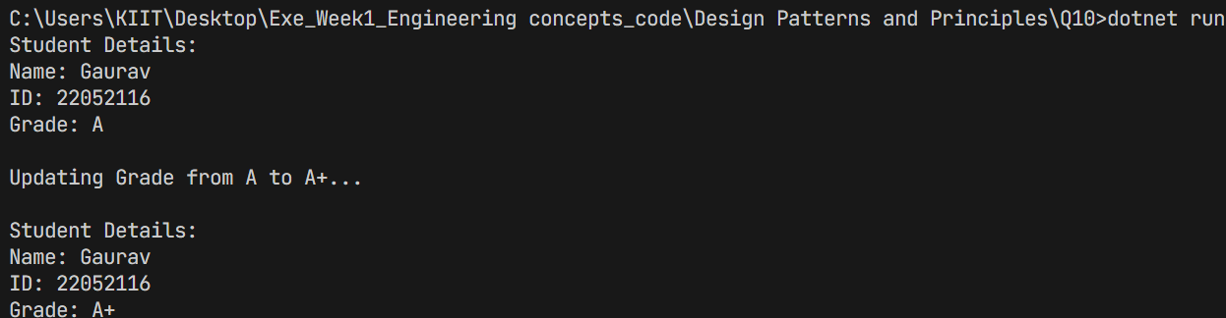

Exercise 11: Implementing Dependency Injection

- Code:

using System;

interface ICustomerRepository { string FindCustomerById(int id); }

class CustomerRepositoryImpl : ICustomerRepository{
public string FindCustomerById(int id){
if (id == 22052116) return $"ID: {id}, Name: Gaurav Kumar";
return $"Customer #{id} not found";
}
}

class CustomerService{
ICustomerRepository repo;
public CustomerService(ICustomerRepository repo) => this.repo = repo;
public void PrintCustomer(int id) => Console.WriteLine(repo.FindCustomerById(id));
}

class Program{
static void Main(){
var service = new CustomerService(new CustomerRepositoryImpl());
service.PrintCustomer(22052116);
}
}

- Output:

- Algorithms and Data Structures

Exercise 1: Inventory Management System
- Code:
using System;
using System.Collections.Generic;

class Product {
public int ProductId { get; set; }
public string ProductName { get; set; }
public int Quantity { get; set; }
public double Price { get; set; }

public Product(int productId, string productName, int quantity, double price) {
ProductId = productId;
ProductName = productName;
Quantity = quantity;
Price = price;
}

public override string ToString() {
return $"ID: {ProductId}, Name: {ProductName}, Qty: {Quantity}, Price: {Price}";
}
}

class InventoryManager {
private Dictionary<int, Product> inventory = new Dictionary<int, Product>();

public void AddProduct(Product product) {
inventory[product.ProductId] = product;
}

public void UpdateProduct(int productId, int newQty, double newPrice) {
if (inventory.ContainsKey(productId)) {
inventory[productId].Quantity = newQty;
inventory[productId].Price = newPrice;
}
}

public void DeleteProduct(int productId) {
inventory.Remove(productId);
}

public void DisplayInventory() {
foreach (var item in inventory.Values) {
Console.WriteLine(item);
}
}
}

class Program {
static void Main(string[] args) {
InventoryManager manager = new InventoryManager();

manager.AddProduct(new Product(1, "Keyboard", 10, 500.0));
manager.AddProduct(new Product(2, "Mouse", 15, 300.0));
manager.DisplayInventory();

Console.WriteLine("\nUpdating product 2...");
manager.UpdateProduct(2, 20, 320.0);

Console.WriteLine("\nDeleting product 1...");
manager.DeleteProduct(1);

Console.WriteLine("\nFinal Inventory:");
manager.DisplayInventory();
}
}

- Output:

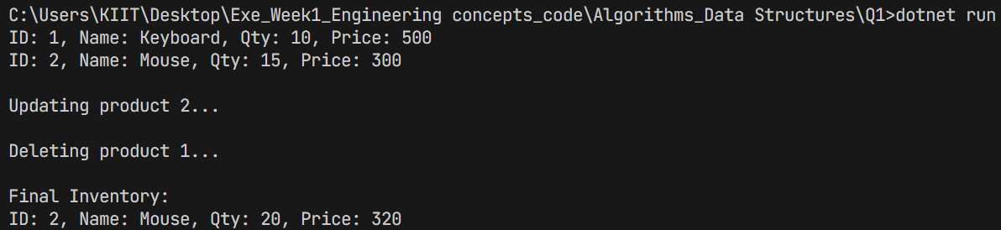

- Analysis:

Using Dictionary<int, Product> (i.e., HashMap):

- Add, Update, Delete - O(1) average time.

- Optimized for large datasets via constant-time hashing.

Exercise 2: E-commerce Platform Search Function
- Code:

using System;

class Product {
public int ProductId { get; set; }
public string ProductName { get; set; }
public string Category { get; set; }

public Product(int productId, string productName, string category) {
ProductId = productId;
ProductName = productName;
Category = category;
}

public override string ToString() {
return $"ID: {ProductId}, Name: {ProductName}, Category: {Category}";
}
}

class SearchFunction {
public static int LinearSearch(Product[] products, string name) {
for (int i = 0; i < products.Length; i++) {
if (products[i].ProductName.Equals(name, StringComparison.OrdinalIgnoreCase)) {
return i;
}
}
return -1;
}

public static int BinarySearch(Product[] products, string name) {
int left = 0, right = products.Length - 1;
while (left <= right) {
int mid = left + (right - left) / 2;
int cmp = string.Compare(products[mid].ProductName, name, StringComparison.OrdinalIgnoreCase);
if (cmp == 0)
return mid;
else if (cmp < 0)
left = mid + 1;
else
right = mid - 1;
}
return -1;
}
}

class Program {
static void Main(string[] args) {
Product[] products = {
new Product(1, "Apple", "Fruits"),
new Product(2, "Banana", "Fruits"),
new Product(3, "Carrot", "Vegetables"),
new Product(4, "Mango", "Fruits")
};

Console.WriteLine("=== Linear Search ===");
int index = SearchFunction.LinearSearch(products, "Carrot");
Console.WriteLine(index != -1 ? $"Found: {products[index]}" : "Product not found");

Array.Sort(products, (p1, p2) => p1.ProductName.CompareTo(p2.ProductName));

Console.WriteLine("\n=== Binary Search ===");
index = SearchFunction.BinarySearch(products, "Mango");
Console.WriteLine(index != -1 ? $"Found: {products[index]}" : "Product not found");
}
}

- Output:

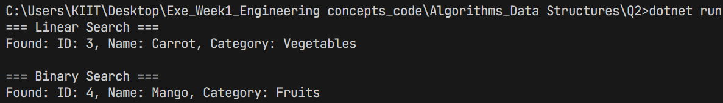

- Analysis:

- Linear Search: O(n)

- Binary Search: O(log n) (on sorted data)

- Use Binary Search for performance-critical scenarios with sorted data.

Exercise 3: Sorting Customer Orders
- Code:

using System;

class Order{
public int OrderId { get; set; }
public string CustomerName { get; set; }
public double TotalPrice { get; set; }

public Order(int id, string name, double price){
OrderId = id;
CustomerName = name;
TotalPrice = price;
}

public override string ToString(){
return $"OrderID: {OrderId}, Name: {CustomerName}, Price: {TotalPrice}";
}
}

class Program{
static void BubbleSort(Order[] orders){
int n = orders.Length;
for (int i = 0; i < n - 1; i++){
for (int j = 0; j < n - i - 1; j++){
if (orders[j].TotalPrice > orders[j + 1].TotalPrice){
var temp = orders[j];
orders[j] = orders[j + 1];
orders[j + 1] = temp;
}
}
}
}

static void QuickSort(Order[] orders, int low, int high){
if (low < high){
int pi = Partition(orders, low, high);
QuickSort(orders, low, pi - 1);
QuickSort(orders, pi + 1, high);
}
}

static int Partition(Order[] orders, int low, int high){
double pivot = orders[high].TotalPrice;
int i = low - 1;
for (int j = low; j < high; j++){
if (orders[j].TotalPrice < pivot){
i++;
var temp = orders[i];
orders[i] = orders[j];
orders[j] = temp;
}
}
var temp2 = orders[i + 1];
orders[i + 1] = orders[high];
orders[high] = temp2;
return i + 1;
}

static void PrintOrders(Order[] orders){
foreach (var order in orders){
Console.WriteLine(order);
}
}

static void Main(string[] args){
Order[] orders = {
new Order(101, "Alice", 5000),
new Order(102, "Bob", 2500),
new Order(103, "Charlie", 8000)
};

Console.WriteLine("Bubble Sort:");
var bubbleSorted = (Order[])orders.Clone();
BubbleSort(bubbleSorted);
PrintOrders(bubbleSorted);

Console.WriteLine("\nQuick Sort:");
var quickSorted = (Order[])orders.Clone();
QuickSort(quickSorted, 0, quickSorted.Length - 1);
PrintOrders(quickSorted);
}
}

- Output:

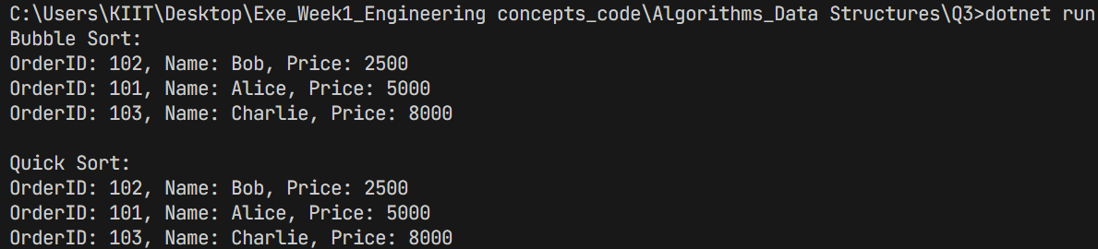

- Analysis:
- Bubble Sort: O(n²)
- Quick Sort: O(n log n) average case
- Quick Sort is better for larger datasets due to divide-and-conquer strategy.

Exercise 4: Employee Management System
- Code:
using System;

class Employee {
public int EmployeeId;
public string Name;
public string Position;
public double Salary;

public Employee(int id, string name, string pos, double sal) {
EmployeeId = id;
Name = name;
Position = pos;
Salary = sal;
}

public void Display() {
Console.WriteLine($"ID: {EmployeeId}, Name: {Name}, Position: {Position}, Salary: {Salary}");
}
}

class Program {
static void Main(string[] args) {
Employee[] employees = new Employee[100];
int count = 0;

employees[count++] = new Employee(1, "Alice", "Manager", 60000);
employees[count++] = new Employee(2, "Bob", "Engineer", 45000);

Console.WriteLine("All Employees:");
for (int i = 0; i < count; i++) {
employees[i].Display();
}

Console.WriteLine("\nSearching Employee with ID 2:");
for (int i = 0; i < count; i++) {
if (employees[i].EmployeeId == 2) {
employees[i].Display();
break;
}
}

Console.WriteLine("\nDeleting Employee with ID 1:");
for (int i = 0; i < count; i++) {
if (employees[i].EmployeeId == 1) {
for (int j = i; j < count - 1; j++) {
employees[j] = employees[j + 1];
}
count--;
break;
}
}

Console.WriteLine("\nEmployees after deletion:");
for (int i = 0; i < count; i++) {
employees[i].Display();
}
}
}
- Output:
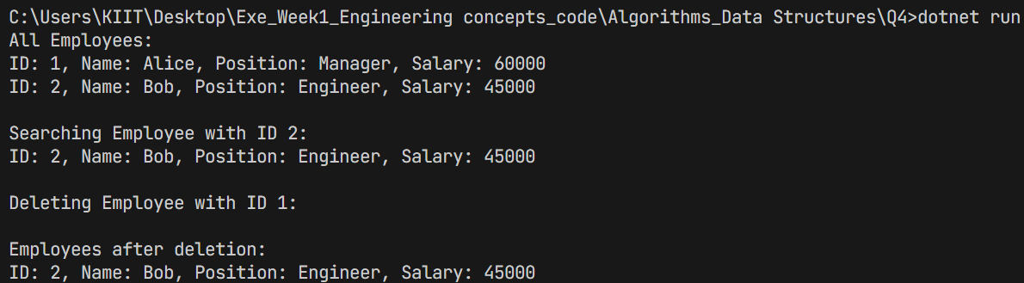

- Analysis:

• Add/Search/Delete: O(n) worst-case

• Arrays are fast for indexed access, but not efficient for dynamic data or frequent insertions/deletions.

Exercise 5: Task Management System
- Code:
using System;

class Task{
public int TaskId;
public string TaskName;
public string Status;
public Task? Next;

public Task(int id, string name, string status){
TaskId = id;
TaskName = name;
Status = status;
Next = null;
}

public void Display() =>
Console.WriteLine($"ID: {TaskId}, Name: {TaskName}, Status: {Status}");
}

class TaskManager{
private Task? head;

public void AddTask(int id, string name, string status){
var newTask = new Task(id, name, status);
if (head == null) head = newTask;
else{
var temp = head;
while (temp.Next != null) temp = temp.Next;
temp.Next = newTask;
}
}

public void DisplayTasks(){
var temp = head;
while (temp != null){
temp.Display();
temp = temp.Next;
}
}

public void DeleteTask(int id){
Task? temp = head, prev = null;

if (temp != null && temp.TaskId == id){
head = temp.Next;
return;
}

while (temp != null && temp.TaskId != id){
prev = temp;
temp = temp.Next;
}

if (temp == null || prev == null) return;

prev.Next = temp.Next;
}
}

class Program
{
static void Main(){
var manager = new TaskManager();
manager.AddTask(1, "Design", "Pending");
manager.AddTask(2, "Code", "In Progress");
manager.AddTask(3, "Test", "Pending");

Console.WriteLine("All Tasks:");
manager.DisplayTasks();

Console.WriteLine("\nDeleting Task with ID 2...");
manager.DeleteTask(2);
manager.DisplayTasks();
}
}
- Output:

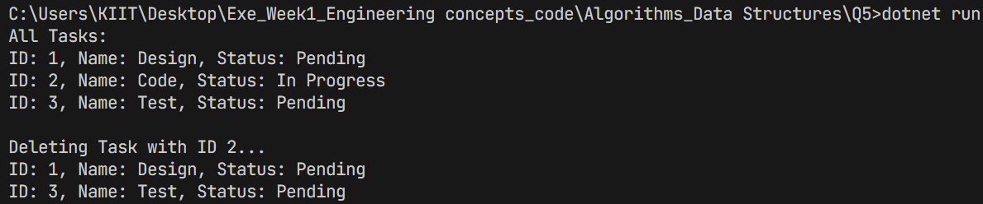
- Analysis:
• Add: O(n) (if added at end)

• Delete/Search: O(n)

• Linked Lists are better for dynamic size and frequent insertions/deletions without shifting elements.

Exercise 6: Library Management System
- Code:
using System;

class Book {
public int BookId;
public string Title;
public string Author;

public Book(int id, string title, string author) {
BookId = id;
Title = title;
Author = author;
}

public void Display() {
Console.WriteLine($"ID: {BookId}, Title: {Title}, Author: {Author}");
}
}

class Program {
static int LinearSearch(Book[] books, string title) {
for (int i = 0; i < books.Length; i++) {
if (books[i].Title.Equals(title, StringComparison.OrdinalIgnoreCase)) return i;
}
return -1;
}

static int BinarySearch(Book[] books, string title) {
int low = 0, high = books.Length - 1;
while (low <= high) {
int mid = (low + high) / 2;
int cmp = string.Compare(books[mid].Title, title, StringComparison.OrdinalIgnoreCase);
if (cmp == 0) return mid;
else if (cmp < 0) low = mid + 1;
else high = mid - 1;
}
return -1;
}

static void Main(string[] args) {
Book[] books = {
new Book(1, "Algorithms", "Cormen"),
new Book(2, "Data Structures", "Lafore"),
new Book(3, "Clean Code", "Martin")
};

Console.WriteLine("Linear Search for 'Data Structures':");
int index = LinearSearch(books, "Data Structures");
if (index != -1) books[index].Display();

Array.Sort(books, (b1, b2) => b1.Title.CompareTo(b2.Title));
Console.WriteLine("\nBinary Search for 'Clean Code':");
index = BinarySearch(books, "Clean Code");
if (index != -1) books[index].Display();
}
}
- Output:

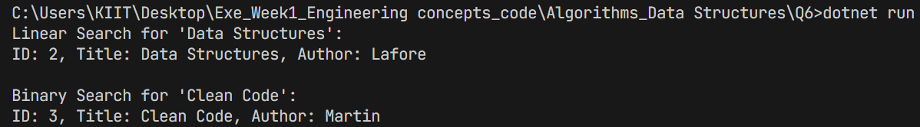
- Analysis:

• Linear: O(n) – good for unsorted or small data sets.

• Binary: O(log n) – works only on sorted arrays.

• Binary Search is better for frequent search operations with large sorted data.

Exercise 7: Financial Forecasting

- Code:

using System;

class Program {
static double PredictFutureValue(double currentValue, double growthRate, int years) {
if (years == 0) return currentValue;
return PredictFutureValue(currentValue * (1 + growthRate), growthRate, years - 1);
}

static double PredictUsingLoop(double currentValue, double growthRate, int years) {
for (int i = 0; i < years; i++) {
currentValue *= (1 + growthRate);
}
return currentValue;
}

static void Main(string[] args) {
double initial = 10000;
double rate = 0.1;
int years = 5;

double futureRecursive = PredictFutureValue(initial, rate, years);
double futureIterative = PredictUsingLoop(initial, rate, years);

Console.WriteLine($"Future Value (Recursive): {futureRecursive}");
Console.WriteLine($"Future Value (Iterative): {futureIterative}");
}
}

- Output:

- Analysis:

• Recursive: O(n) time, O(n) space (stack)

• Optimized (iterative): O(n) time, O(1) space

• Use loops or memoization to reduce stack overhead.

